Distinguished AlumnUS Awards – 2023

The following are the final selected nominees for the Distinguished Alumnus Awards (DAA) 2023:

Sl No | Photo | DAA Award Category | Name of the Nominee | Present Position
1. | 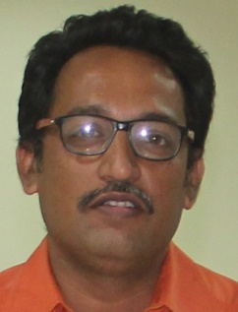 | Professional Excellence –  Academic and Research | Dr Kaushik Kumar  B.Tech (Mech) - 1990 | Professor, Department of Mechanical Engineering, Birla Institute of Technology, Mesra, Ranchi, Jharkhand
2. | 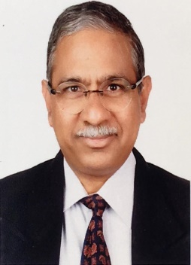 | Professional Excellence –  Industry / Corporate | Dr. Srinivas Mantrala  B.Tech (Civil) - 1986 | Head, Fixed Infrastructure, Nacala Logistics Corridor, Vulcan International, Mozambique
3. | 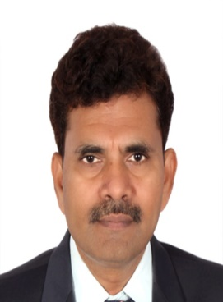 | Professional Excellence – Industry / Corporate | Shri. VNR Nayudu  B.Tech (MET) - 1993 | Chief General Manager, India Government Mint Hyderabad
4. | 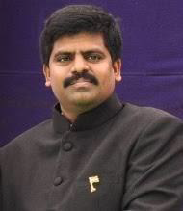 | Public Service – Public Administration | Shri. Muthyala Raju Revu  B.Tech (EEE) - 2002 | Principal Secretary to Andhra Pradesh State Government
5. | 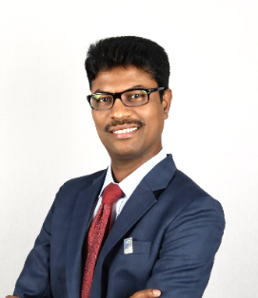 | Public Service – Social & Community Service | Shri. Raja Srinivasa Rao Aita  B.Tech (Civil) - 1994 | Lead Project Light-Abu Dhabi National Oil Company, Abu Dhabi (ADNOC Offshore)

